Download MariaDB from this link: <https://mariadb.com/downloads/>

Make sure you choose “10.4.13-GA” version and your PC’ OS

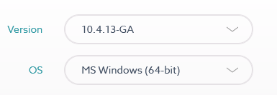

Install MariaDB on your PC with all default settings, set username as “root” and password as “root”

Paste and extract the file “sudokudb.zip” in

C:\Program Files\MariaDB 10.4\data (or a different directory where you locate MariaDB on your PC)

Now you can run the game and check the data in MariaDB by doing the following steps:

* Search for MySQL Client (MariaDB 10.4) in StartMenu/Programs

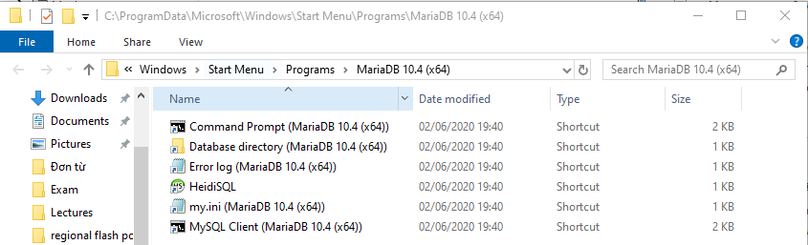

Another way to do this is to open cmd and enter this line to connect to MariaDB



* Enter password as “root”
* Enter this line “use sudokudb”



* “show tables”  
  